**NAAN MUDHALVAN**

SALESFORCE PROJECT REPORT

COLLEGE : **PONJESLY COLLEGE OF ENGINEERING**

BATCH-18

|  |  |  |
| --- | --- | --- |
| **NAME** | **NM ID** | **REG NO** |
| CHITHAMBARAM.KR | B7FDCDCA58780B59AAF4183FA8BAD2E6 | 961820114067 |

**Step 1: Create a Salesforce Account**

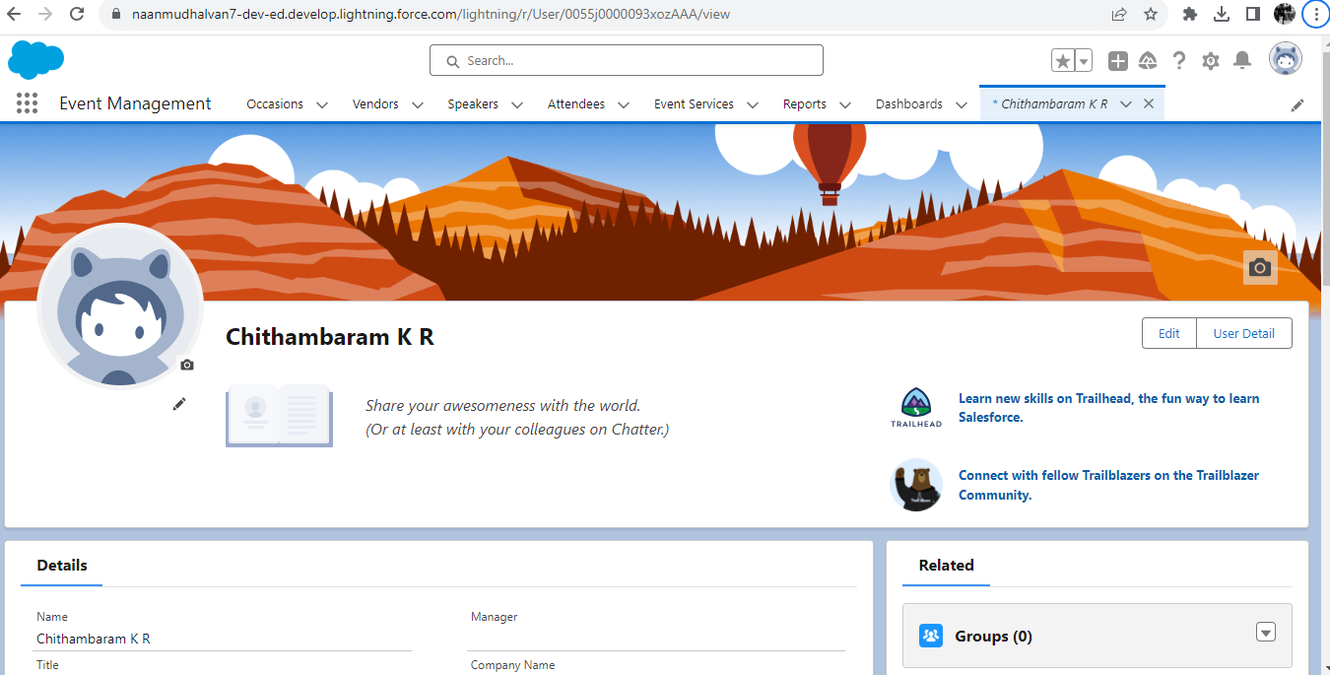

**Step 2: Create the objects (Attendee,Speaker,Vendor,Event Service,Occasion)**

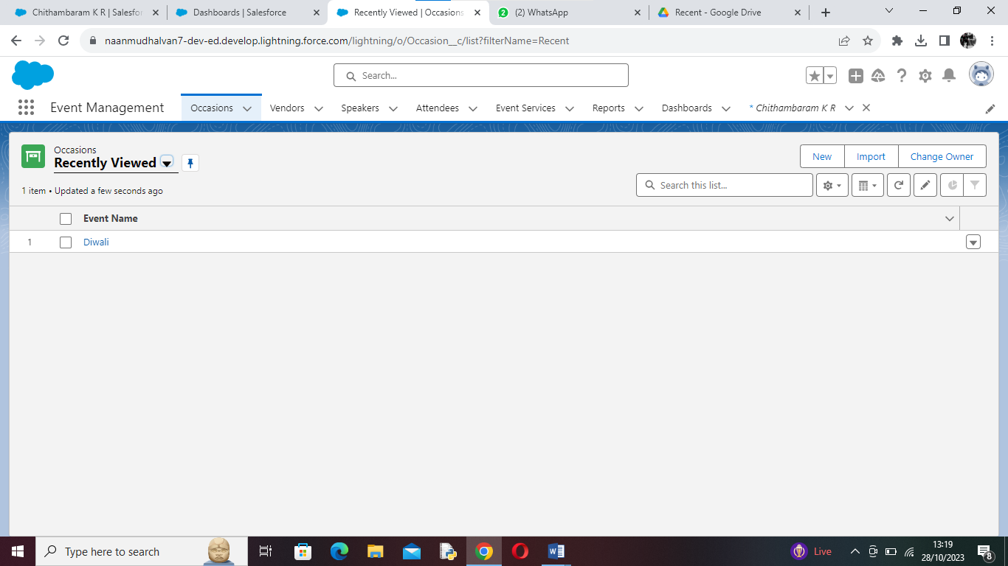

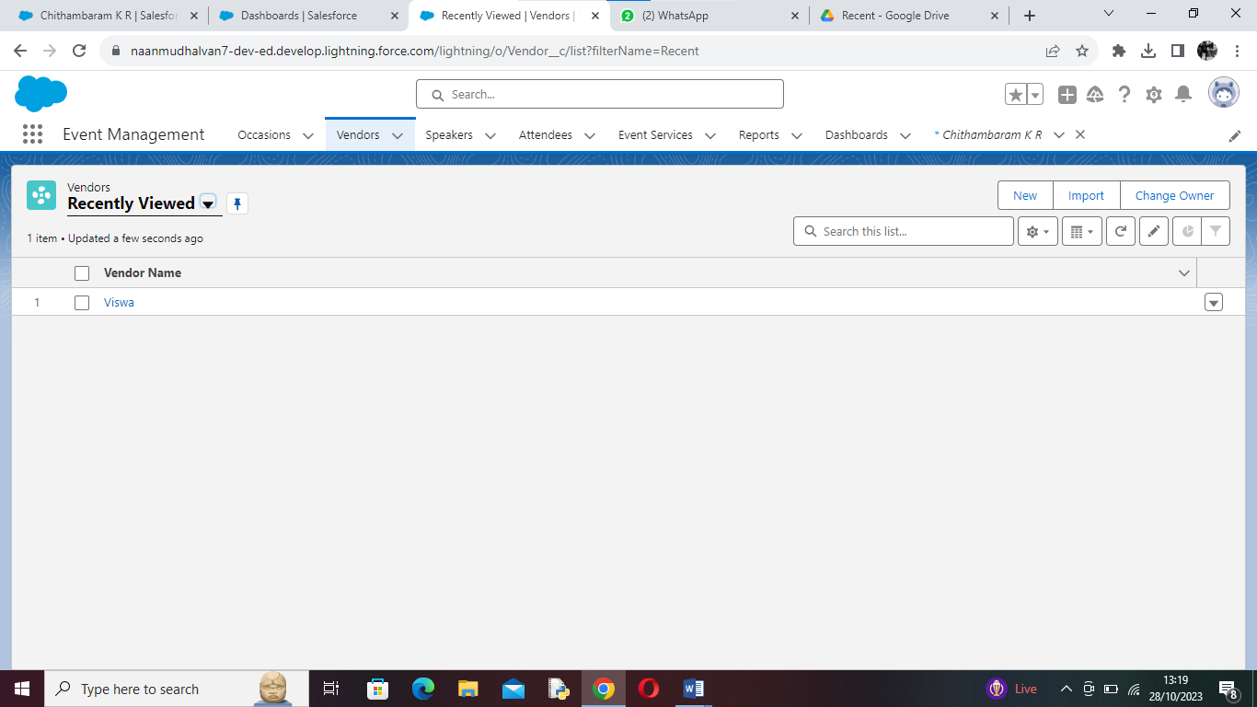

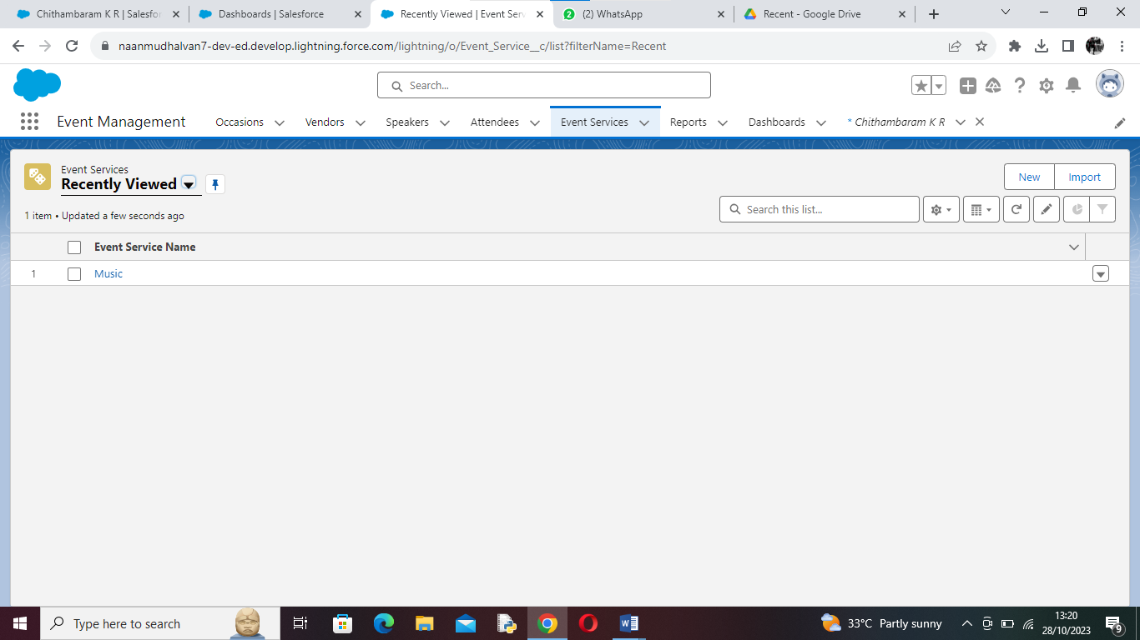

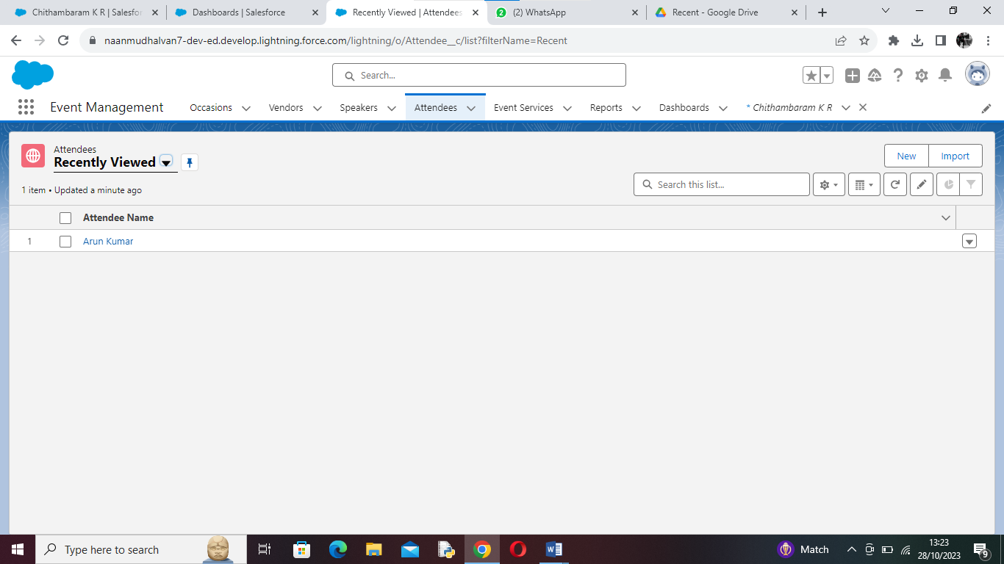

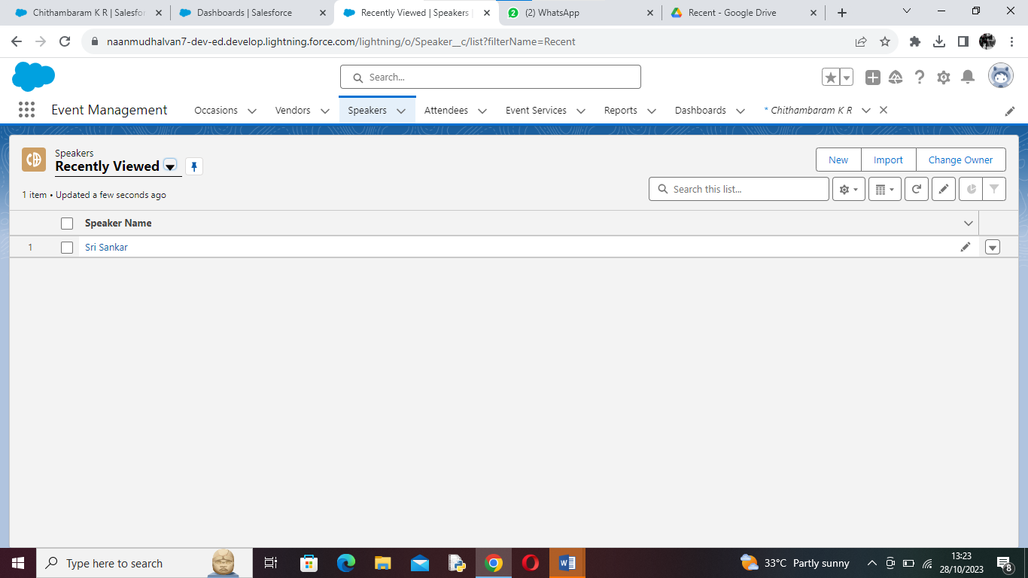

**Step 3: Create the Tabs for each objects (Attendee,Speaker,Vendor,Event Service,Occasion)**

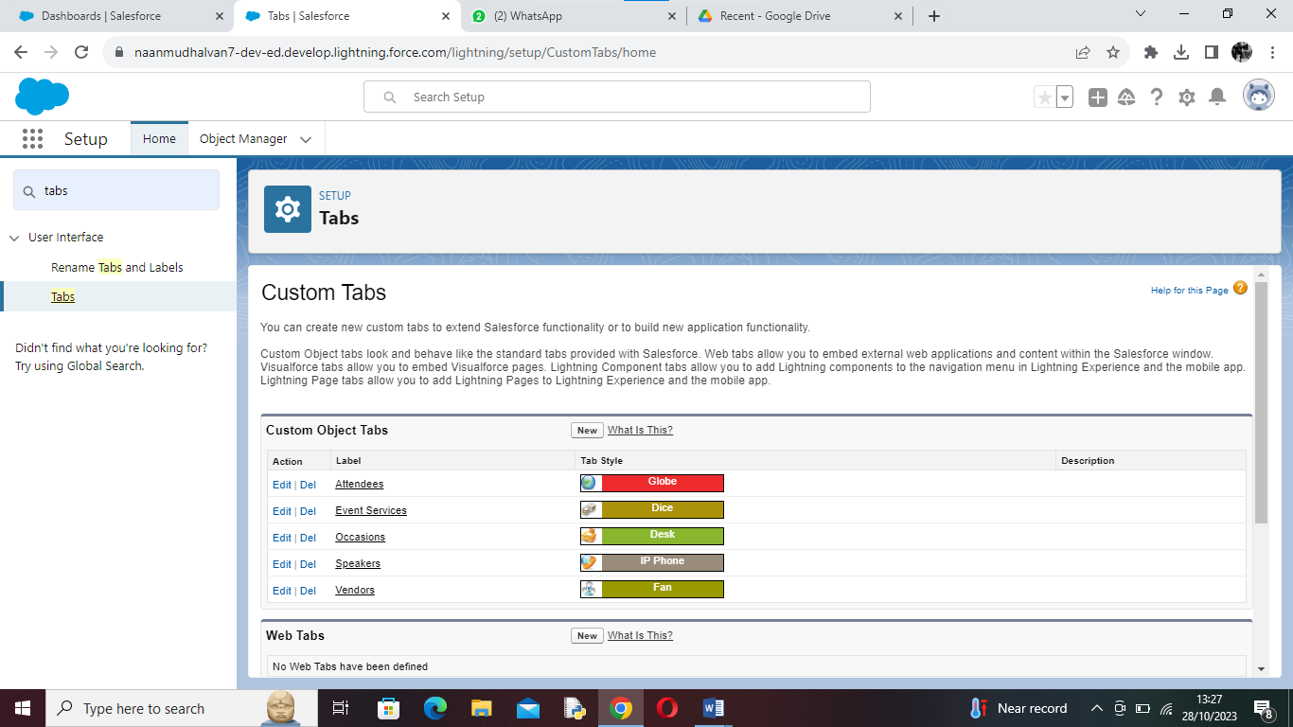

**Step 4: Create a Lightining App**

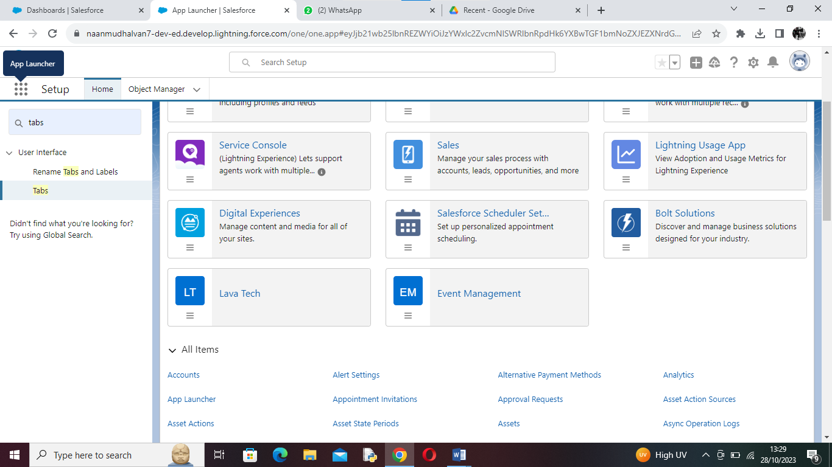

**Step 5: Create the Fields & Relationship for each objects**

